附录
附表1 鄂尔多斯市短历时暴雨强度查算表
q： L/（s·hm²）
降雨历时  （min)  重现期（年） | 5 | 10 | 15 | 20 | 30 | 45 | 60 | 90 | 120 | 150 | 180
2 | 243.945 | 199.146 | 170.472 | 150.280 | 123.348 | 99.117 | 83.944 | 66.215 | 55.479 | 48.242 | 42.978
3 | 276.886 | 226.038 | 193.491 | 170.573 | 139.999 | 112.499 | 95.273 | 75.157 | 62.971 | 54.757 | 48.781
5 | 318.387 | 259.918 | 222.493 | 196.140 | 160.979 | 129.359 | 109.556 | 86.421 | 72.409 | 62.964 | 56.093
10 | 374.700 | 305.890 | 261.845 | 230.831 | 189.445 | 152.233 | 128.928 | 101.707 | 85.216 | 74.100 | 66.014
20 | 431.013 | 351.862 | 301.198 | 265.523 | 217.912 | 175.106 | 148.300 | 116.992 | 98.023 | 85.237 | 75.935
30 | 463.955 | 378.753 | 324.217 | 285.816 | 234.563 | 188.488 | 159.629 | 125.934 | 105.515 | 91.751 | 81.738
50 | 505.456 | 412.633 | 353.219 | 311.382 | 255.542 | 205.348 | 173.913 | 137.198 | 114.953 | 99.958 | 89.050
100 | 561.769 | 458.605 | 392.571 | 346.073 | 284.009 | 228.221 | 193.285 | 152.484 | 127.760 | 111.095 | 98.971

附表2 鄂尔多斯市长历时暴雨强度查算表
q： L/(s·hm²)
降雨历时  （min)  重现期（年） | 240 | 360 | 540 | 720 | 1440
2 | 24.464 | 17.991 | 13.187 | 10.564 | 6.171
3 | 31.257 | 23.161 | 17.104 | 13.774 | 8.148
5 | 40.556 | 30.302 | 22.563 | 18.276 | 10.964
10 | 50.770 | 38.104 | 28.495 | 23.151 | 13.988
20 | 61.386 | 46.185 | 34.619 | 28.171 | 17.085
30 | 66.703 | 50.214 | 37.659 | 30.656 | 18.606
40 | 70.516 | 53.112 | 39.851 | 32.450 | 19.710
50 | 73.548 | 55.421 | 41.602 | 33.887 | 20.598
60 | 76.104 | 57.373 | 43.087 | 35.107 | 21.355
70 | 77.908 | 58.736 | 44.112 | 35.943 | 21.864
80 | 79.904 | 25.218 | 18.947 | 15.443 | 9.400
90 | 81.275 | 61.304 | 46.061 | 37.543 | 22.854
100 | 82.959 | 62.601 | 47.055 | 38.364 | 23.370

表3 鄂尔多斯市重现期2a短历时lmin间隔的设计暴雨雨型结果
降水历时（min） | 降水强度（mm/min）
降水历时（min） | 30min | 60min | 90min | 120min | 150min | 180min
1 | 0.386 | 0.219 | 0.159 | 0.128 | 0.108 | 0.095
2 | 0.417 | 0.227 | 0.163 | 0.13 | 0.11 | 0.096
3 | 0.455 | 0.236 | 0.167 | 0.132 | 0.111 | 0.097
4 | 0.501 | 0.246 | 0.171 | 0.135 | 0.113 | 0.098
5 | 0.557 | 0.257 | 0.176 | 0.137 | 0.114 | 0.099
6 | 0.63 | 0.269 | 0.181 | 0.14 | 0.116 | 0.1
7 | 0.725 | 0.283 | 0.186 | 0.143 | 0.118 | 0.101
8 | 0.856 | 0.298 | 0.191 | 0.146 | 0.12 | 0.103
9 | 1.047 | 0.315 | 0.197 | 0.149 | 0.121 | 0.104
10 | 1.343 | 0.334 | 0.204 | 0.152 | 0.123 | 0.105
11 | 1.861 | 0.356 | 0.211 | 0.155 | 0.125 | 0.107
12 | 1.624 | 0.382 | 0.218 | 0.159 | 0.127 | 0.108
13 | 1.354 | 0.413 | 0.226 | 0.163 | 0.13 | 0.109
14 | 1.159 | 0.45 | 0.235 | 0.167 | 0.132 | 0.111
15 | 1.012 | 0.494 | 0.245 | 0.171 | 0.134 | 0.112
16 | 0.898 | 0.549 | 0.256 | 0.175 | 0.137 | 0.114
17 | 0.808 | 0.619 | 0.267 | 0.18 | 0.14 | 0.116
18 | 0.734 | 0.711 | 0.281 | 0.185 | 0.142 | 0.117
19 | 0.673 | 0.837 | 0.296 | 0.191 | 0.145 | 0.119
20 | 0.622 | 1.017 | 0.312 | 0.197 | 0.148 | 0.121
21 | 0.578 | 1.296 | 0.331 | 0.203 | 0.151 | 0.123
22 | 0.54 | 1.774 | 0.353 | 0.21 | 0.155 | 0.125
23 | 0.507 | 1.667 | 0.379 | 0.217 | 0.158 | 0.127
24 | 0.478 | 1.384 | 0.409 | 0.225 | 0.162 | 0.129
25 | 0.453 | 1.181 | 0.444 | 0.234 | 0.166 | 0.132
26 | 0.43 | 1.029 | 0.488 | 0.244 | 0.17 | 0.134
27 | 0.41 | 0.912 | 0.541 | 0.254 | 0.175 | 0.137
28 | 0.391 | 0.819 | 0.609 | 0.266 | 0.179 | 0.139
29 | 0.375 | 0.743 | 0.698 | 0.279 | 0.184 | 0.142
30 | 0.36 | 0.68 | 0.818 | 0.294 | 0.19 | 0.145
31 |  | 0.628 | 0.989 | 0.31 | 0.196 | 0.148
32 |  | 0.583 | 1.252 | 0.329 | 0.202 | 0.151
33 |  | 0.545 | 1.694 | 0.35 | 0.209 | 0.154
34 |  | 0.511 | 1.712 | 0.375 | 0.216 | 0.158
35 |  | 0.482 | 1.415 | 0.405 | 0.224 | 0.162
36 |  | 0.456 | 1.204 | 0.439 | 0.233 | 0.165
37 |  | 0.433 | 1.047 | 0.482 | 0.242 | 0.17
38 |  | 0.412 | 0.926 | 0.534 | 0.253 | 0.174
39 |  | 0.394 | 0.83 | 0.599 | 0.264 | 0.179
40 |  | 0.377 | 0.752 | 0.685 | 0.277 | 0.184
41 |  | 0.361 | 0.688 | 0.8 | 0.292 | 0.189
42 |  | 0.347 | 0.634 | 0.963 | 0.308 | 0.195
43 |  | 0.335 | 0.588 | 1.21 | 0.326 | 0.201
44 |  | 0.323 | 0.549 | 1.62 | 0.347 | 0.208
45 |  | 0.312 | 0.515 | 1.759 | 0.372 | 0.215
46 |  | 0.302 | 0.485 | 1.448 | 0.4 | 0.223
47 |  | 0.292 | 0.459 | 1.228 | 0.435 | 0.232
48 |  | 0.284 | 0.436 | 1.065 | 0.476 | 0.241
49 |  | 0.275 | 0.415 | 0.94 | 0.526 | 0.251
50 |  | 0.268 | 0.396 | 0.841 | 0.59 | 0.263
51 |  | 0.261 | 0.379 | 0.761 | 0.672 | 0.275
52 |  | 0.254 | 0.363 | 0.695 | 0.783 | 0.29
53 |  | 0.248 | 0.349 | 0.641 | 0.938 | 0.306
54 |  | 0.242 | 0.336 | 0.594 | 1.171 | 0.324
55 |  | 0.236 | 0.324 | 0.554 | 1.552 | 0.344
56 |  | 0.23 | 0.313 | 0.519 | 1.809 | 0.368
57 |  | 0.225 | 0.303 | 0.489 | 1.482 | 0.396
58 |  | 0.221 | 0.294 | 0.462 | 1.253 | 0.43
59 |  | 0.216 | 0.285 | 0.439 | 1.084 | 0.47
60 |  | 0.212 | 0.277 | 0.417 | 0.954 | 0.519
61 |  |  | 0.269 | 0.398 | 0.853 | 0.581
62 |  |  | 0.262 | 0.381 | 0.771 | 0.66
63 |  |  | 0.255 | 0.365 | 0.703 | 0.766
64 |  |  | 0.248 | 0.351 | 0.647 | 0.915
65 |  |  | 0.242 | 0.338 | 0.6 | 1.135
66 |  |  | 0.237 | 0.326 | 0.559 | 1.49
67 |  |  | 0.231 | 0.315 | 0.524 | 1.861
68 |  |  | 0.226 | 0.304 | 0.493 | 1.518
69 |  |  | 0.221 | 0.295 | 0.466 | 1.279
70 |  |  | 0.217 | 0.286 | 0.442 | 1.103
71 |  |  | 0.212 | 0.278 | 0.42 | 0.969
72 |  |  | 0.208 | 0.27 | 0.401 | 0.865
73 |  |  | 0.204 | 0.262 | 0.383 | 0.78
74 |  |  | 0.2 | 0.256 | 0.367 | 0.711
75 |  |  | 0.196 | 0.249 | 0.353 | 0.654
76 |  |  | 0.193 | 0.243 | 0.34 | 0.605
77 |  |  | 0.189 | 0.237 | 0.327 | 0.564
78 |  |  | 0.186 | 0.232 | 0.316 | 0.528
79 |  |  | 0.183 | 0.227 | 0.306 | 0.497
80 |  |  | 0.18 | 0.222 | 0.296 | 0.469
81 |  |  | 0.177 | 0.217 | 0.287 | 0.445
82 |  |  | 0.175 | 0.213 | 0.279 | 0.423
83 |  |  | 0.172 | 0.208 | 0.271 | 0.403
84 |  |  | 0.169 | 0.204 | 0.263 | 0.385
85 |  |  | 0.167 | 0.201 | 0.256 | 0.369
86 |  |  | 0.164 | 0.197 | 0.25 | 0.355
87 |  |  | 0.162 | 0.193 | 0.244 | 0.341
88 |  |  | 0.16 | 0.19 | 0.238 | 0.329
89 |  |  | 0.158 | 0.187 | 0.233 | 0.317
90 |  |  | 0.156 | 0.184 | 0.227 | 0.307
91 |  |  |  | 0.181 | 0.222 | 0.297
92 |  |  |  | 0.178 | 0.218 | 0.288
93 |  |  |  | 0.175 | 0.213 | 0.28
94 |  |  |  | 0.172 | 0.209 | 0.272
95 |  |  |  | 0.17 | 0.205 | 0.264
96 |  |  |  | 0.167 | 0.201 | 0.257
97 |  |  |  | 0.165 | 0.197 | 0.251
98 |  |  |  | 0.162 | 0.194 | 0.245
99 |  |  |  | 0.16 | 0.19 | 0.239
100 |  |  |  | 0.158 | 0.187 | 0.233
101 |  |  |  | 0.156 | 0.184 | 0.228
102 |  |  |  | 0.154 | 0.181 | 0.223
103 |  |  |  | 0.152 | 0.178 | 0.218
104 |  |  |  | 0.15 | 0.175 | 0.214
105 |  |  |  | 0.148 | 0.173 | 0.21
106 |  |  |  | 0.146 | 0.17 | 0.205
107 |  |  |  | 0.145 | 0.167 | 0.202
108 |  |  |  | 0.143 | 0.165 | 0.198
109 |  |  |  | 0.141 | 0.163 | 0.194
110 |  |  |  | 0.14 | 0.16 | 0.191
111 |  |  |  | 0.138 | 0.158 | 0.188
112 |  |  |  | 0.137 | 0.156 | 0.184
113 |  |  |  | 0.135 | 0.154 | 0.181
114 |  |  |  | 0.134 | 0.152 | 0.178
115 |  |  |  | 0.132 | 0.15 | 0.176
116 |  |  |  | 0.131 | 0.148 | 0.173
117 |  |  |  | 0.129 | 0.147 | 0.17
118 |  |  |  | 0.128 | 0.145 | 0.168
119 |  |  |  | 0.127 | 0.143 | 0.165
120 |  |  |  | 0.126 | 0.141 | 0.163
121 |  |  |  |  | 0.14 | 0.161
122 |  |  |  |  | 0.138 | 0.159
123 |  |  |  |  | 0.137 | 0.156
124 |  |  |  |  | 0.135 | 0.154
125 |  |  |  |  | 0.134 | 0.152
126 |  |  |  |  | 0.132 | 0.15
127 |  |  |  |  | 0.131 | 0.149
128 |  |  |  |  | 0.13 | 0.147
129 |  |  |  |  | 0.128 | 0.145
130 |  |  |  |  | 0.127 | 0.143
131 |  |  |  |  | 0.126 | 0.142
132 |  |  |  |  | 0.125 | 0.14
133 |  |  |  |  | 0.123 | 0.138
134 |  |  |  |  | 0.122 | 0.137
135 |  |  |  |  | 0.121 | 0.135
136 |  |  |  |  | 0.12 | 0.134
137 |  |  |  |  | 0.119 | 0.133
138 |  |  |  |  | 0.118 | 0.131
139 |  |  |  |  | 0.117 | 0.13
140 |  |  |  |  | 0.116 | 0.128
141 |  |  |  |  | 0.115 | 0.127
142 |  |  |  |  | 0.114 | 0.126
143 |  |  |  |  | 0.113 | 0.125
144 |  |  |  |  | 0.112 | 0.124
145 |  |  |  |  | 0.111 | 0.122
146 |  |  |  |  | 0.11 | 0.121
147 |  |  |  |  | 0.109 | 0.12
148 |  |  |  |  | 0.108 | 0.119
149 |  |  |  |  | 0.108 | 0.118
150 |  |  |  |  | 0.107 | 0.117
151 |  |  |  |  |  | 0.116
152 |  |  |  |  |  | 0.115
153 |  |  |  |  |  | 0.114
154 |  |  |  |  |  | 0.113
155 |  |  |  |  |  | 0.112
156 |  |  |  |  |  | 0.111
157 |  |  |  |  |  | 0.11
158 |  |  |  |  |  | 0.109
159 |  |  |  |  |  | 0.108
160 |  |  |  |  |  | 0.108
161 |  |  |  |  |  | 0.107
162 |  |  |  |  |  | 0.106
163 |  |  |  |  |  | 0.105
164 |  |  |  |  |  | 0.104
165 |  |  |  |  |  | 0.104
166 |  |  |  |  |  | 0.103
167 |  |  |  |  |  | 0.102
168 |  |  |  |  |  | 0.101
169 |  |  |  |  |  | 0.101
170 |  |  |  |  |  | 0.100
171 |  |  |  |  |  | 0.099
172 |  |  |  |  |  | 0.099
173 |  |  |  |  |  | 0.098
174 |  |  |  |  |  | 0.097
175 |  |  |  |  |  | 0.097
176 |  |  |  |  |  | 0.096
177 |  |  |  |  |  | 0.095
178 |  |  |  |  |  | 0.095
179 |  |  |  |  |  | 0.094
180 |  |  |  |  |  | 0.093

附表4 历时1440min设计暴雨雨型各时段（时段长：5min）比例表（单位：%）
时段 | 时长/min
时段 | H1440_H720 | H720_H360 | H360_H240 | H240_H180 | H180_H150 | H150_H120 | H120_H90 | H90_H60 | H60_H45 | H45_H30 | H30_H15 | H15_H5 | H5
1 | 0.254
2 | 0.383
3 | 0.657
4 | 0.373
5 | 0.245
6 | 0.123
7 | 0.083
8 | 0.060
9 | 0.083
10 | 0.143
11 | 0.090
12 | 0.083
13 | 0.120
14 | 0.214
15 | 0.184
16 | 0.428
17 | 0.833
18 | 0.929
19 | 0.829
20 | 0.362
21 | 0.277
22 | 0.554
23 | 0.800
24 | 1.440
25 | 2.752
26 | 1.376
27 | 0.579
28 | 0.353
29 | 1.282
30 | 1.093
31 | 1.111
32 | 1.923
33 | 1.748
34 | 0.726
35 | 0.411
36 | 0.461
37 | 0.565
38 | 0.777
39 | 0.631
40 | 0.214
41 | 0.214
42 | 0.308
43 | 0.285
44 | 0.196
45 | 0.538
46 | 0.529
47 | 0.191
48 | 0.173
49 | 0.183
50 | 0.218
51 | 0.400
52 | 0.290
53 | 0.748
54 | 0.925
55 | 2.021
56 | 1.335
57 | 1.898
58 | 2.820
59 | 3.334
60 | 1.785
61 | 1.527
62 | 1.041
63 | 0.252
64 | 0.181
65 | 0.150
66 | 0.171
67 | 0.163
68 | 0.264
69 | 0.730
70 | 0.442
71 | 0.842
72 | 0.582
73 | 0.361
74 | 1.665
75 | 1.592
76 | 1.213
77 | 1.207
78 | 0.604
79 | 0.964
80 | 1.129
81 | 1.649
82 | 1.100
83 | 0.797
84 | 0.595
85 | 0.672
86 | 1.358
87 | 1.718
88 | 1.015
89 | 1.236
90 | 3.196
91 | 3.726
92 | 2.306
93 | 1.687
94 | 1.143
95 | 1.004
96 | 0.992
97 | 1.401
98 | 2.048
99 | 0.652
100 | 0.586
101 | 0.524
102 | 0.488
103 | 0.278
104 | 0.297
105 | 0.188
106 | 0.275
107 | 0.268
108 | 0.217
109 | 0.185
110 | 0.057
111 | 0.149
112 | 0.356
113 | 0.316
114 | 0.407
115 | 0.352
116 | 0.171
117 | 0.180
118 | 0.090
119 | 0.069
120 | 0.075
121 | 0.151
122 | 0.111
123 | 0.072
124 | 0.113
125 | 0.068
126 | 0.084
127 | 0.084
128 | 0.178
129 | 0.291
130 | 0.207
131 | 0.158
132 | 0.254
133 | 0.215
134 | 0.215
135 | 0.809
136 | 0.641
137 | 0.522
138 | 0.409
139 | 0.467
140 | 0.482
141 | 0.539
142 | 0.441
143 | 0.332
144 | 0.314
145 |  | 0.412
146 |  | 0.233
147 |  | 0.425
148 |  | 0.420
149 |  | 0.314
150 |  | 0.553
151 |  | 0.306
152 |  | 0.084
153 |  | 0.186
154 |  | 1.207
155 |  | 1.893
156 |  | 1.468
157 |  | 0.679
158 |  | 0.318
159 |  | 0.322
160 |  | 0.680
161 |  | 0.911
162 |  | 0.268
163 |  | 0.599
164 |  | 0.266
165 |  | 0.367
166 |  | 0.741
167 |  | 2.012
168 |  | 1.663
169 |  | 2.232
170 |  | 1.431
171 |  | 0.955
172 |  | 1.014
173 |  | 1.301
174 |  | 1.625
175 |  | 2.715
176 |  | 3.243
177 |  | 1.434
178 |  | 0.848
179 |  | 0.832
180 |  | 1.114
181 |  | 1.156
182 |  | 1.481
183 |  | 2.493
184 |  | 1.715
185 |  | 1.975
186 |  | 2.100
187 |  | 2.096
188 |  | 2.330
189 |  | 2.341
190 |  | 1.798
191 |  | 1.328
192 |  | 1.437
193 |  | 2.238
194 |  | 1.909
195 |  | 2.168
196 |  |  | 2.531
197 |  |  | 4.323
198 |  |  | 5.027
199 |  |  | 4.362
200 |  |  | 4.556
201 |  |  | 5.032
202 |  |  |  | 8.624
203 |  |  |  | 8.663
204 |  |  |  | 7.325
205 |  |  |  | 7.349
206 |  |  |  | 7.662
207 |  |  |  | 8.286
208 |  |  |  | 8.159
209 |  |  |  | 7.229
210 |  |  |  | 9.670
211 |  |  |  | 9.325
212 |  |  |  |  |  | 14.890
213 |  |  |  |  |  | 14.275
214 |  |  |  |  |  | 14.463
215 |  |  |  |  |  | 17.795
216 |  |  |  |  |  |  |  |  |  |  | 46.933
217 |  |  |  |  |  |  |  |  |  |  |  | 46.961
218 |  |  |  |  |  |  |  |  |  |  |  |  | 100
219 |  |  |  |  |  |  |  |  |  |  |  | 53.039
220 |  |  |  |  |  |  |  |  |  |  | 31.147
221 |  |  |  |  |  |  |  |  |  |  | 21.920
222 |  |  |  |  |  |  |  |  |  | 31.955
223 |  |  |  |  |  |  |  |  |  | 35.981
224 |  |  |  |  |  |  |  |  |  | 32.065
225 |  |  |  |  |  |  |  |  | 26.462
226 |  |  |  |  |  |  |  |  | 35.450
227 |  |  |  |  |  |  |  |  | 38.088
228 |  |  |  |  |  |  |  | 19.899
229 |  |  |  |  |  |  |  | 18.286
230 |  |  |  |  |  |  |  | 17.381
231 |  |  |  |  |  |  |  | 17.981
232 |  |  |  |  |  |  |  | 9.324
233 |  |  |  |  |  |  |  | 17.129
234 |  |  |  |  |  |  | 12.445
235 |  |  |  |  |  |  | 18.797
236 |  |  |  |  |  |  | 11.216
237 |  |  |  |  |  |  | 14.050
238 |  |  |  |  |  |  | 22.325
239 |  |  |  |  |  |  | 21.167
240 |  |  |  |  |  | 20.817
241 |  |  |  |  |  | 17.760
242 |  |  |  |  | 23.922
243 |  |  |  |  | 21.027
244 |  |  |  |  | 11.817
245 |  |  |  |  | 10.705
246 |  |  |  |  | 13.615
247 |  |  |  |  | 18.914
248 |  |  |  | 9.095
249 |  |  |  | 8.613
250 |  |  | 5.528
251 |  |  | 4.673
252 |  |  | 3.953
253 |  |  | 3.833
254 |  |  | 3.240
255 |  |  | 3.015
256 |  |  | 3.790
257 |  |  | 3.525
258 |  |  | 3.985
259 |  |  | 4.069
260 |  |  | 3.256
261 |  |  | 4.051
262 |  |  | 5.100
263 |  |  | 5.322
264 |  |  | 4.009
265 |  |  | 3.763
266 |  |  | 3.690
267 |  |  | 5.367
268 |  | 2.134
269 |  | 1.600
270 |  | 1.625
271 |  | 2.015
272 |  | 1.585
273 |  | 1.602
274 |  | 3.415
275 |  | 2.482
276 |  | 1.500
277 |  | 1.977
278 |  | 1.597
279 |  | 1.078
280 |  | 2.054
281 |  | 1.264
282 |  | 1.195
283 |  | 1.225
284 |  | 1.719
285 |  | 2.188
286 |  | 2.467
287 |  | 0.957
288 |  | 0.688

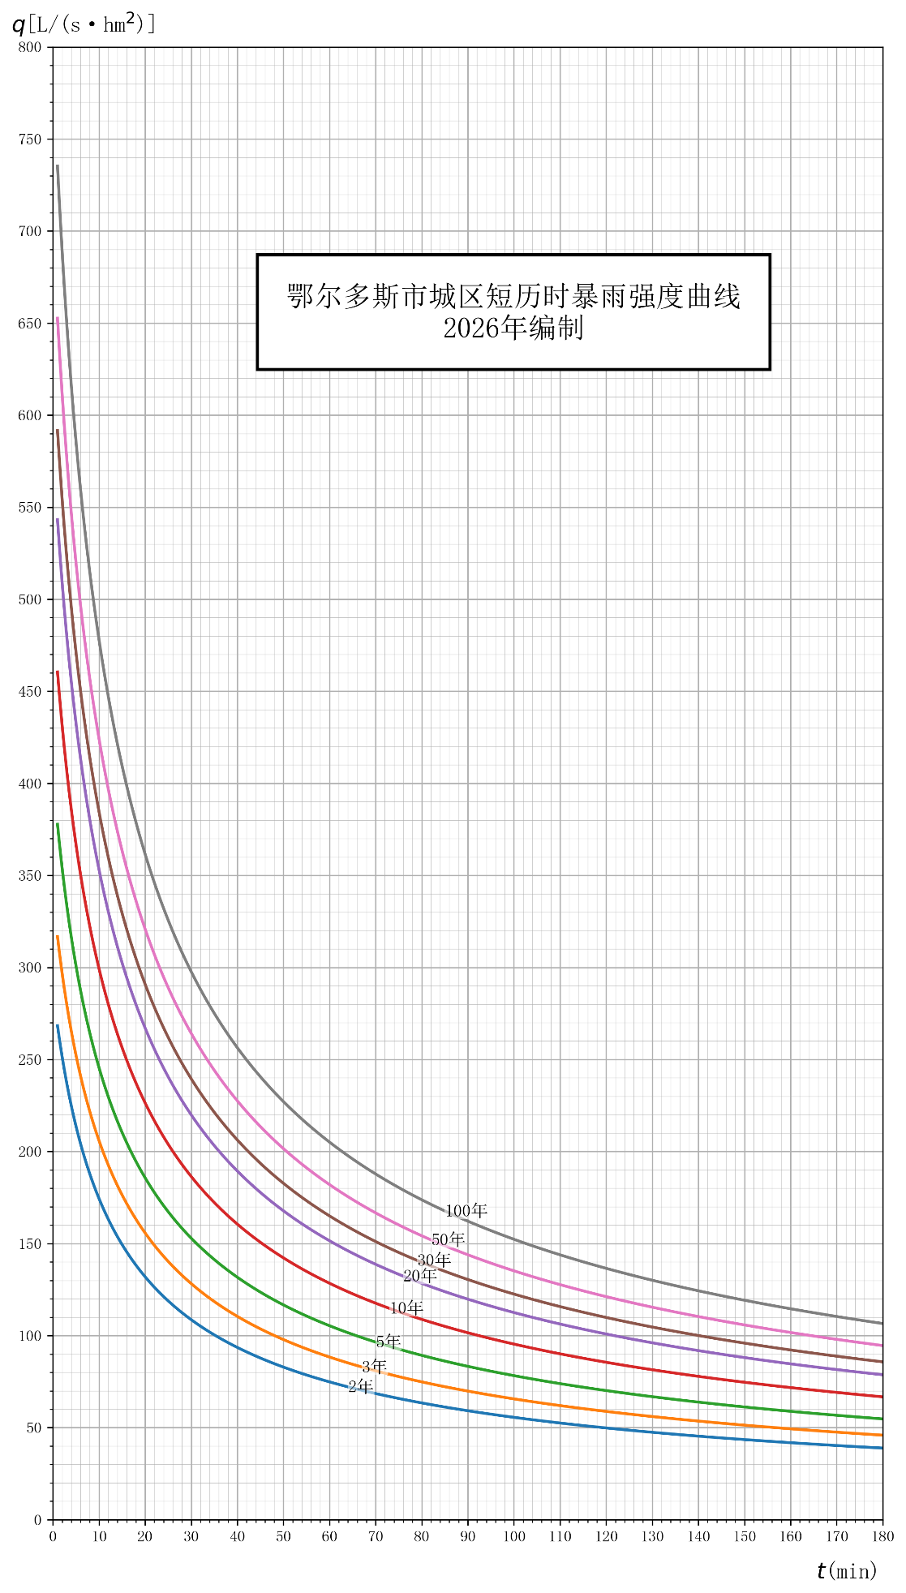
附图1 短历时p-i-t关系曲线图

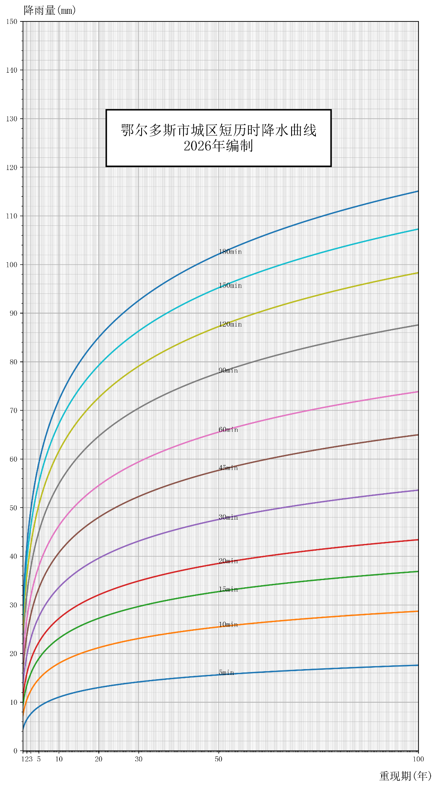
附图2 短历时不同降雨历时的暴雨强度频率曲线图

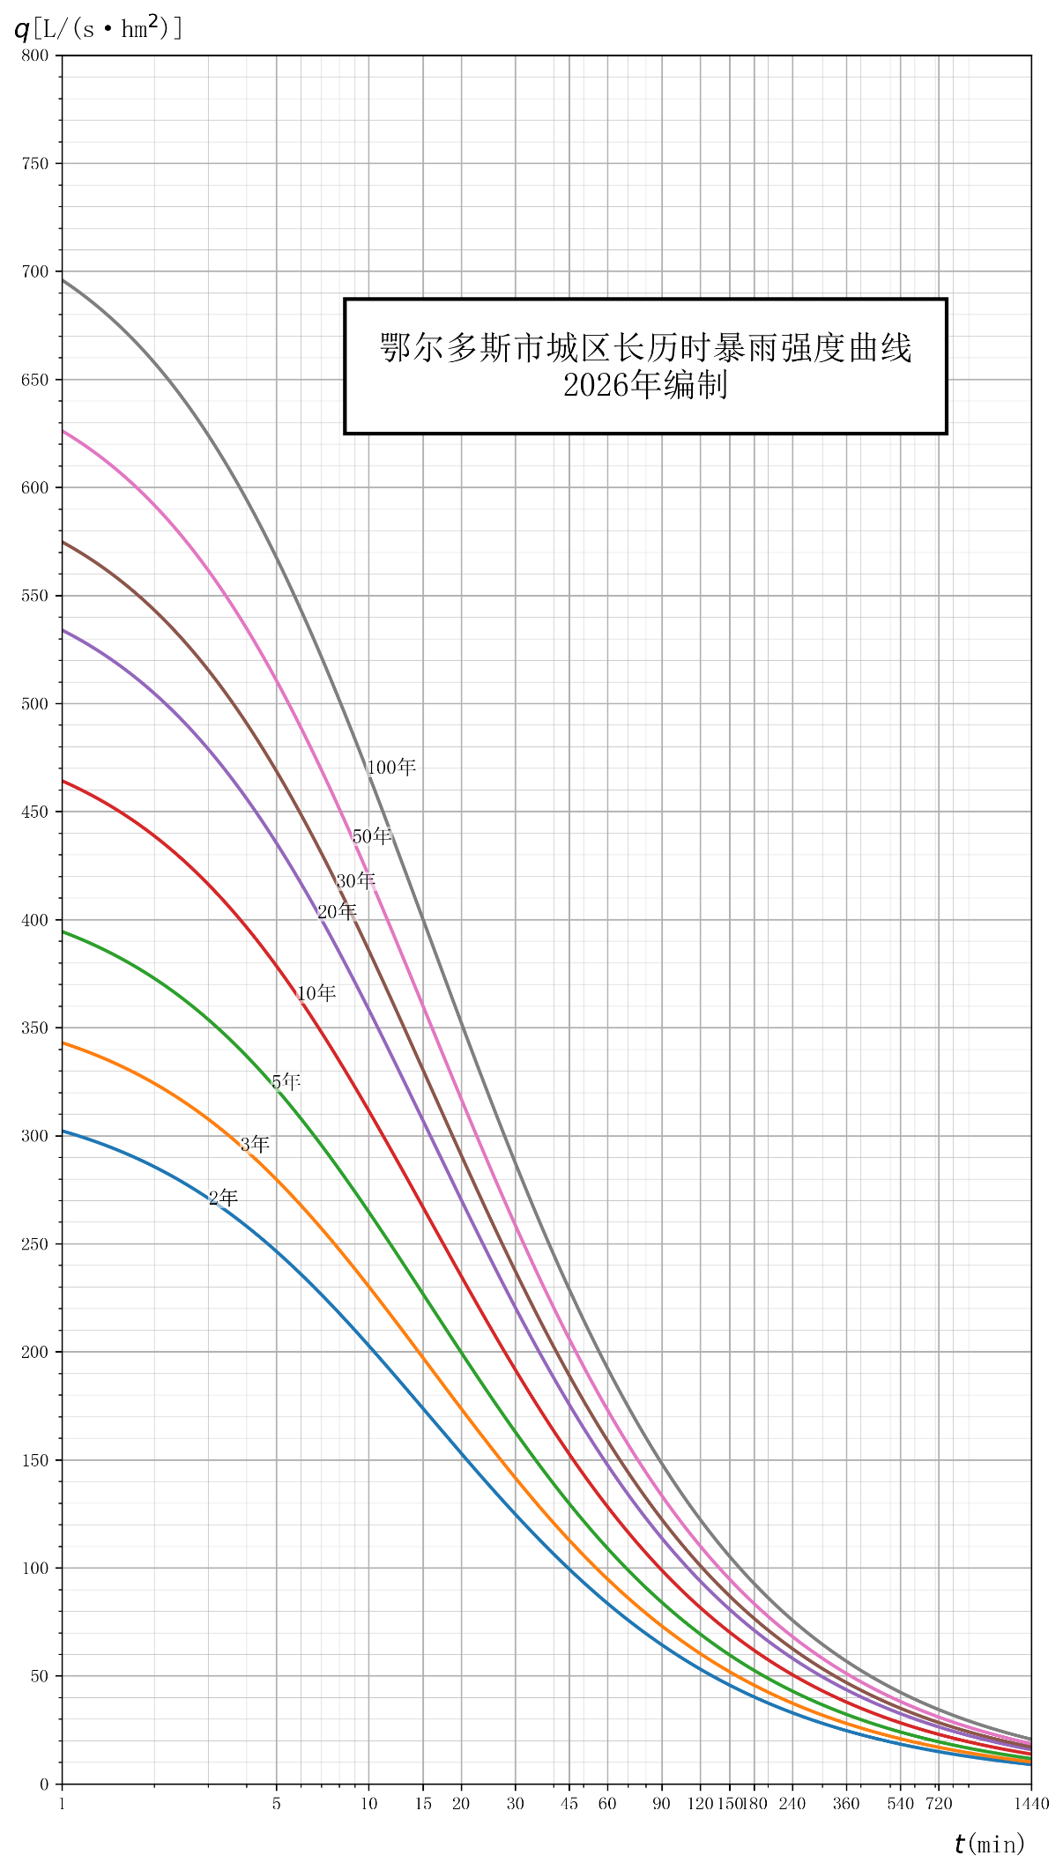
附图3 长历时p-i-t关系曲线图

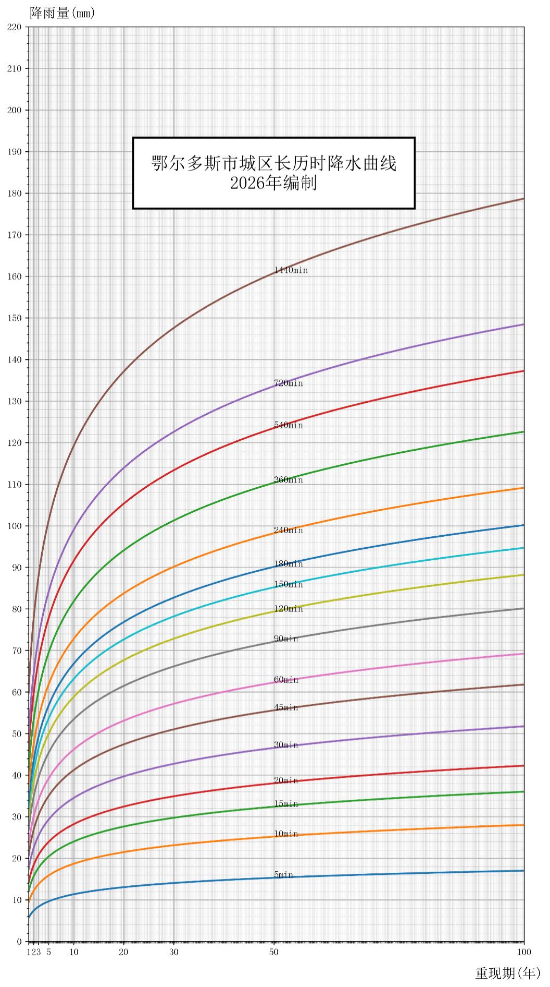
附图4 长历时不同降雨历时的暴雨强度频率曲线图

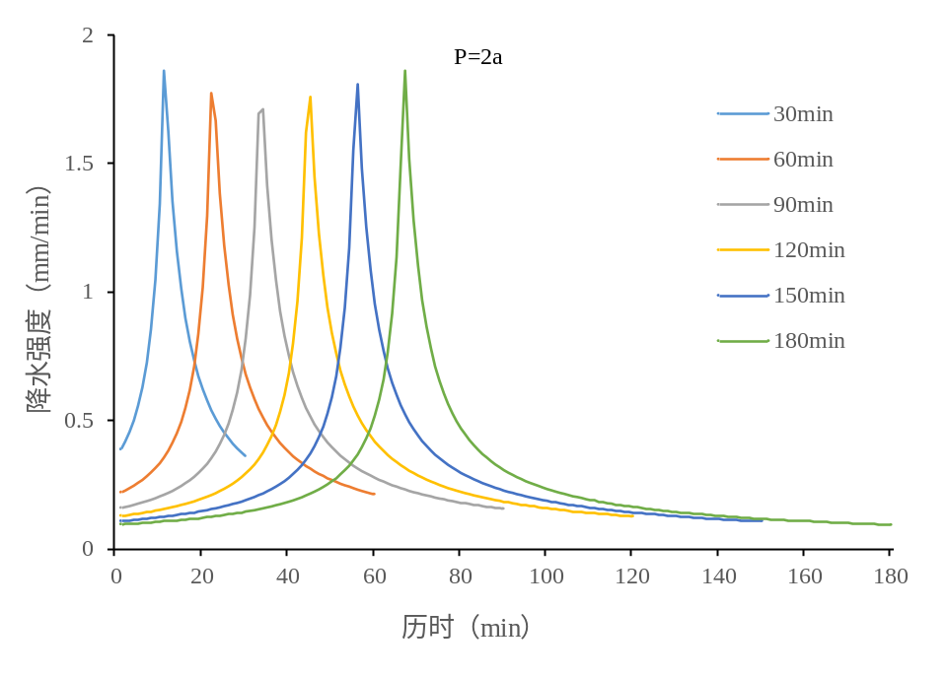
附图5.1 芝加哥法推求重现期2a短历时设计暴雨雨型分布图

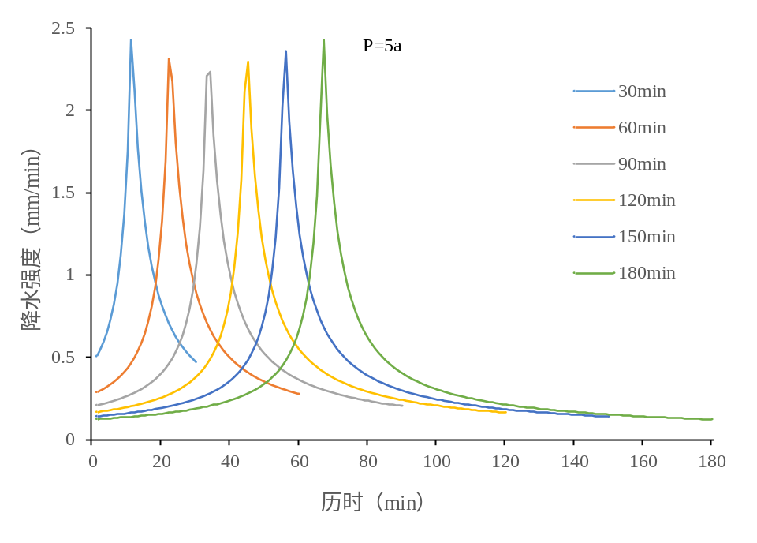
附图5.2 芝加哥法推求重现期5a短历时设计暴雨雨型分布图

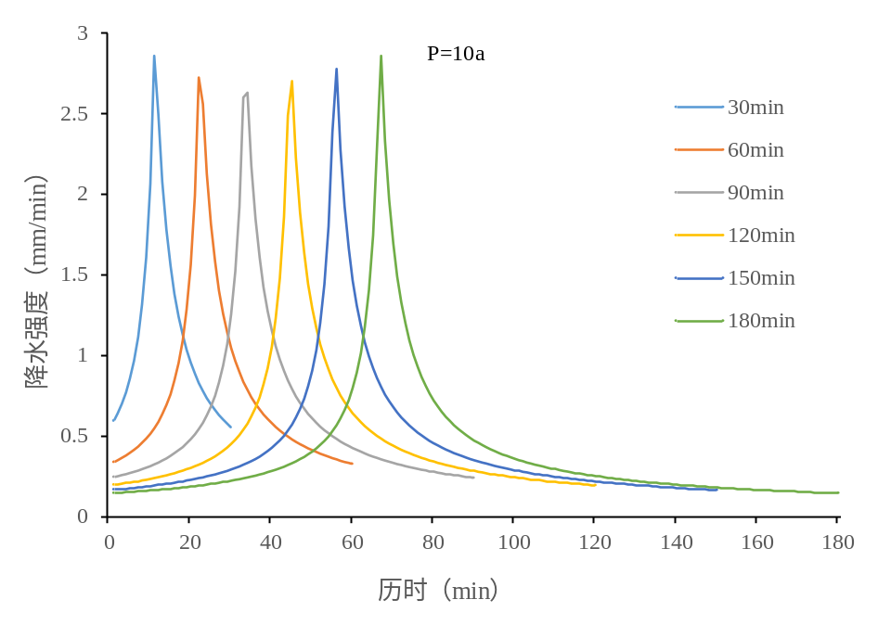
附图5.3 芝加哥法推求重现期10a短历时设计暴雨雨型分布图
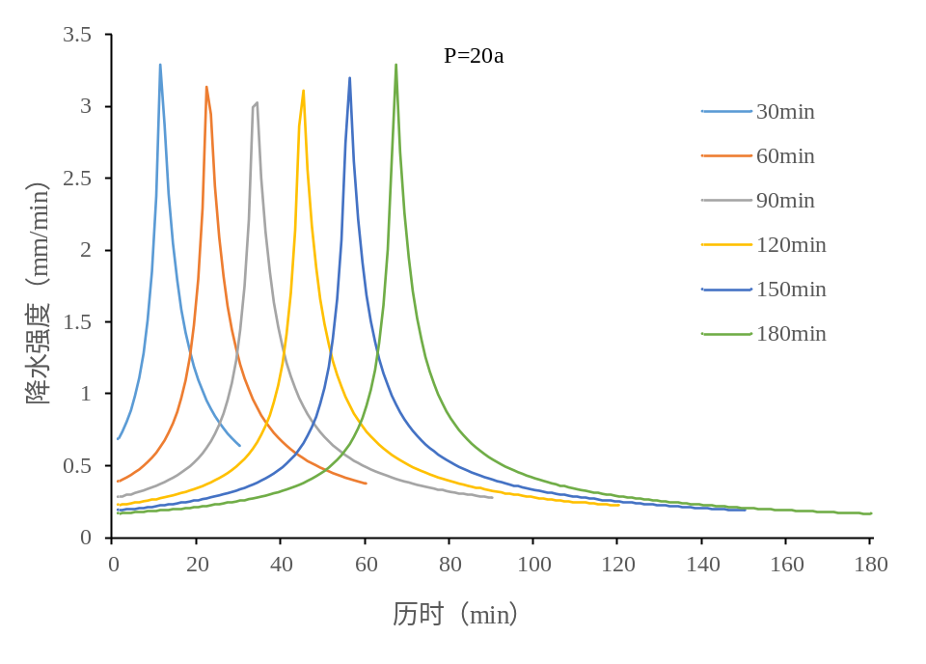
附图5.4 芝加哥法推求重现期20a短历时设计暴雨雨型分布图

